# Silent Install of Biztalk 2009

## Getting custom configuration settings

### Internet Information Services (IIS) 6.0 or 7.0

The command below installs IIS 7.0 with all the services available. Choose only the services required by your web applications.

*pkgmgr.exe /iu:IIS-WebServerRole;IIS-WebServer;IIS-CommonHttpFeatures;IIS-StaticContent;IIS-DefaultDocument;IIS-DirectoryBrowsing;IIS-HttpErrors;IIS-HttpRedirect;IIS-ApplicationDevelopment;IIS-ASPNET;IIS-NetFxExtensibility;IIS-ASP;IIS-CGI;IIS-ISAPIExtensions;IIS-ISAPIFilter;IIS-ServerSideIncludes;IIS-HealthAndDiagnostics;IIS-HttpLogging;IIS-LoggingLibraries;IIS-RequestMonitor;IIS-HttpTracing;IIS-CustomLogging;IIS-ODBCLogging;IIS-Security;IIS-BasicAuthentication;IIS-WindowsAuthentication;IIS-DigestAuthentication;IIS-ClientCertificateMappingAuthentication;IIS-IISCertificateMappingAuthentication;IIS-URLAuthorization;IIS-RequestFiltering;IIS-IPSecurity;IIS-Performance;IIS-HttpCompressionStatic;IIS-HttpCompressionDynamic;IIS-WebServerManagementTools;IIS-ManagementConsole;IIS-ManagementScriptingTools;IIS-ManagementService;IIS-IIS6ManagementCompatibility;IIS-Metabase;IIS-WMICompatibility;IIS-LegacyScripts;IIS-LegacySnapIn;IIS-FTPPublishingService;IIS-FTPServer;IIS-FTPManagement;WAS-WindowsActivationService;WAS-ProcessModel;WAS-NetFxEnvironment;WAS-ConfigurationAPI*

### Microsoft Office Excel 2007

1. Ensure you have an actual VLK (some call it enterprise/corporate) disc & product-key.

2. Notably, o2k7 uses setup patches (*.MSP) for uA, rather than transforms which previous versions used (*.MST). The below instructions will give you an MSP file, which is not accepted by non-corporate versions of o2k7. If you ignored point1 above, then you will end up wasting 15 minutes of your life which I'm not responsible for.

3. Now at the command prompt, type: setup.exe /admin

4. Choose the product for which you want to make a customization-patch.

5. Then go through all steps in the customization wizard (to install the reqd apps & remove junk & change default settings).

6. Be sure to have "completion notice" turned on & "suppress modals" turned off (this is to get to see errors, if any exist). Once you're done with testing, go thru the customization again to modify the MSP to disable completion notice & enable suppress modals.

7. Save the resulting patch file in the same folder as o2k7 setup files.

8. Now just execute this command (thru any method) for silent install: setup.exe /adminfile CUSTOM.MSP

Or if you have the Office 2007 Enterprise VLK, you could even drop the CUSTOM.MSP file in the "Updates" folder & setup will pick it up automatically (without any switches being used). For this, ensure you have WindowsInstaller 3.1 already installed. You can add in further MSP files (extracted from SP1 update EXE) as well, to have updates applied during install.

*** For completely silent install, you MUST set the DisplayLevel to "none", either by MSP (accessible from step 6 above) or by xml, otherwise you'll get a confirmation dialog similar to the image shown in attachment below. (do this only AFTER testing, when you're sure it works)

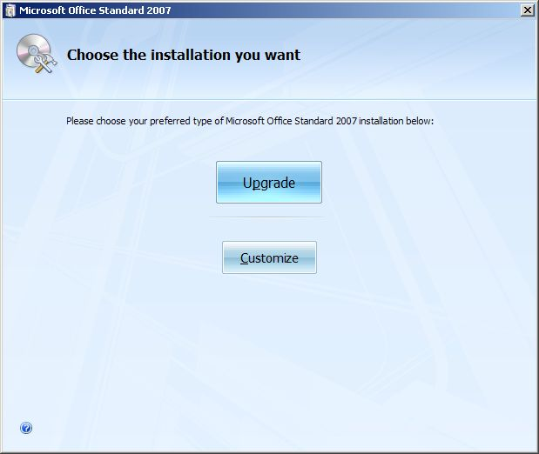

### Visual Studio® 2008

Run the following command

Setup\setup.exe /CreateUnattend *[full path filename]* and chose the aspirate settings

### SQL Server 2008

Install sql 2008 as you normally would, once you get to **Ready to Install** screen there is a directory location to the config.ini file.

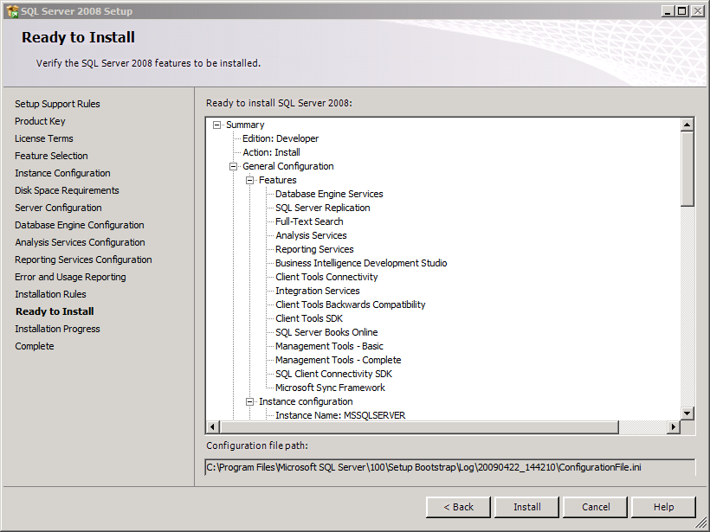

## Base Build Setup

### 1 - Base Image Setup

A base image is windows OS installed and updated with the latest patches. The reason why you sysprep a machine is that you cannot add two machines to a domain that have the same computer SID and name. Both SID and name have to be unique. You can only perform sysprep a limited number (~4) of times. So have an original machine and cloned machine of the original that you sysprep.

### 2 – Powershell

Powershell needs to be installed and set the execution Policy to unrestricted by running **Set-**

**ExecutionPolicy Unrestricted** in the powershell command prompt.

## Install files

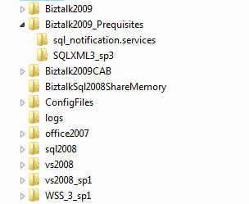

Copy all the appropriate install files to the desired location

## Process Flow



## Running

1. Copy directory installfiles from \\sg-b2b-host\SilentInstall\ to *[new server]* C drive
2. Check c:\installfiles\run.config OrderToInstall section to make sure what is to be installed
3. Run c:\installfiles\run.bat

## Things Left To Do

* Configure Windows SharePoint Services
* Disable the Shared Memory Protocol
* Configure BizTalk Server

# Apendix

## Apendix A - Sysprepping a virtual machine with guest OS win2000, win2003 and XP

I learned how to do this at TechEd 2004 in a lab led by Robert Larson, one of our resident Virtual Server gurus.

You can create a “base” virtual machine with the operating system and applications you want, and then copy its .vhd file to use for other virtual machines. When you do this, it’s important to run a tool called Sysprep on the base virtual machine. That way, when you start a virtual machine that uses a copy of the base virtual machine’s .vhd file, the guest operating system will be assigned a new SID, GUID, MAC address, and so forth when it starts up. This way you won’t end up with network conflicts between different virtual machines that use the same copied .vhd file.

**Important Notes:**

* + Do not perform this procedure on the host computer!! Perform it only within the guest operating system of the virtual machine you want to clone.
  + Microsoft does not support using a tool other than Sysprep for cloning virtual machines. For more information, see this Knowledge Base article: [**http://support.microsoft.com/Default.aspx?id=162001**](http://support.microsoft.com/Default.aspx?id=162001).

Step 1: Install the Setup Manager files in your guest operating system

* + Set up a base virtual machine by installing the operating system, service pack, patches, applications, and so forth that you want to clone.
  + Start the guest operating system and log on as a local administrator.
  + From the guest operating system, go to the Microsoft Web site and download the appropriate Sysprep version. Extract the files to a folder such as C:\Tools on the guest hard disk. You can obtain the SysPrep files from the following locations:  
    Windows 2000:  <http://www.microsoft.com/windows2000/downloads/tools/sysprep/default.asp>  
    Windows XP:  <http://www.microsoft.com/downloads/details.aspx?FamilyID=7a83123d-507b-4095-9d9d-0a195f7b5f69&DisplayLang=en>  
    Windows XP SP2 and Windows Server 2003:  <http://www.microsoft.com/downloads/details.aspx?FamilyID=3e90dc91-ac56-4665-949b-beda3080e0f6&displaylang=en&Hash=RWRPDM9>

Step 2: Create an answer file

Note: This procedure applies to the Sysprep version for Windows Server 2003. You’ll need to modify the steps for other versions of Sysprep. The files that you extracted from the Microsoft Web site include a help file named Deploy.chm that has specific information for your version. It's a good idea to read the help file and become familiar with this tool and figure out how to customize the following steps for your own environment and purposes.

* 1. In the Tools folder on the local disk of the guest operating system, double click Setupmgr.exe to start the Setup Manager wizard.
  2. Click "Next."
  3. Select "Create New" and click "Next."
  4. Select "Sysprep Setup" and click "Next."
  5. Select the type of guest operating system and click "Next."
  6. Select "Yes – Fully automate the installation" and click "Next."
  7. Type a name and organization, click "Next."
  8. Accept the default display settings by clicking "Next."
  9. Select your home time zone and click "Next."
  10. In Product Key type the product key and click "Next."
  11. In licensing, select the type of license for the guest operating system, and click "Next."
  12. Type a computer name for the guest operating system and click "Next."
  13. Set the administrator password and click "Next."
  14. To ensure that the password will be set, the machine’s password must be blank.  Press Right-ALT + DEL and click "Change Password." Type the old password and leave the new password blank. Click "OK."
  15. Select "Typical Settings" and click "Next."
  16. Leave the machine in a workgroup and click "Next."
  17. Customize the next few screens of additional settings as necessary. If you don't know what they're for, accept the defaults.
  18. In "Identification String" type the computer name and click "Finish."
  19. Specify C:\Tools\Sysprep\sysprep.inf for the location for the .inf file.
  20. Click "Cancel" to close the Setup Manager wizard.
  21. You now have a C:\sysprep folder with your sysprep file and copy stored at C:\tools\sysprep\sysprep.inf.    
      Copy Sysprep.exe and Setupcl.exe from C:\Tools\Sysprep to C:\Sysprep.

Step 3 – Sysprep the guest operating system

* 1. Close all windows in the guest operating system.
  2. Click "Start" and then "Run."
  3. Type C:\sysprep\sysprep.exe and press Enter.
  4. This starts the Sysprep process. Click "OK" to clear the warning dialog.
  5. Select "Do not reset grace period for activation."
  6. Make sure that the shutdown mode is "Shutdown."
  7. Click "Reseal."
  8. When prompted about regenerating SIDS, click "OK." The guest operating system will be Sysprepd and will automatically shut down.
  9. Remove the base .vhd file from the virtual machine, and in the file system, make the base.vhd file read-only. You need to do this because you do not want to start a virtual machine by using this base .vhd file. If you do, it will undo the whole process that you just went through.

You can now make copies of this .vhd file and attach them to different virtual machines. After you copy the .vhd file, you need to remove the copy’s read-only attribute. When you start a virtual machine with a copied .vhd file, it will receive a unique SID and other identifiers. You can also use the base .vhd file as the parent drive image for several differencing drives. The unique identifiers for each guest operating system built in this way will thus be written into the differencing drives, and not the parent.

Note: The fourth time you run Sysprep on the same media, you receive the message, "Your grace period limit has been reached and will not be reset." For more information, see <http://support.microsoft.com/default.aspx?scid=299840>.

## Appendix B - Sysprepping a virtual machine with guest OS win2008

There are several "gotchas" to be aware of that didn't exist for Windows Server 2003. The first one is Sysprep in Windows 2000 Server and Windows Server 2003 consisted of three files -- **SYSPREP.EXE**, **SETUPMGR.EXE** and **SETUPCL.EXE** -- found on the Windows Server CD in the \Support directory.

Windows Server 2008, on the other hand, has Sysprep built right into the OS, found at C:\windows\system32\sysprep\sysprep.exe. That's it -- just sysprep.exe.

In the virtual machine, you can run sysprep.exe either from the command line or from the GUI. From the command line, enter:

**sysprep /OOBE /Generalize /shutdown.**

Note that if you enter Sysprep without any options set, the GUI will appear and prompt you, as shown in Figure 1. It is important to use the /shutdown option rather than the /reboot option, since /shutdown allows you to make copies of the setup image (/reboot goes right to setup and creates a new machine). You can find more details on this in the Microsoft step-by-step guide on [Windows Deployment Services update](http://technet2.microsoft.com/WindowsVista/en/library/9e197135-6711-4c20-bfad-fc80fc2151301033.mspx?mfr=true).

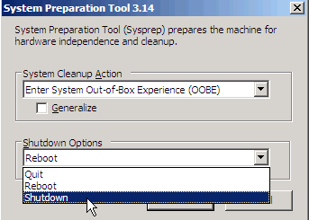

Another change from Windows Server 2003, of course, is the choice you now have between *full version* and *Server Core*. Early in the installation, you are presented with the screen shown in Figure 2. In your test environment, in order to have both versions, you will need to install one of each. That is, install one machine as *full version*, Sysprep it and save it. Then install another machine as *Server Core*, and do the same.

